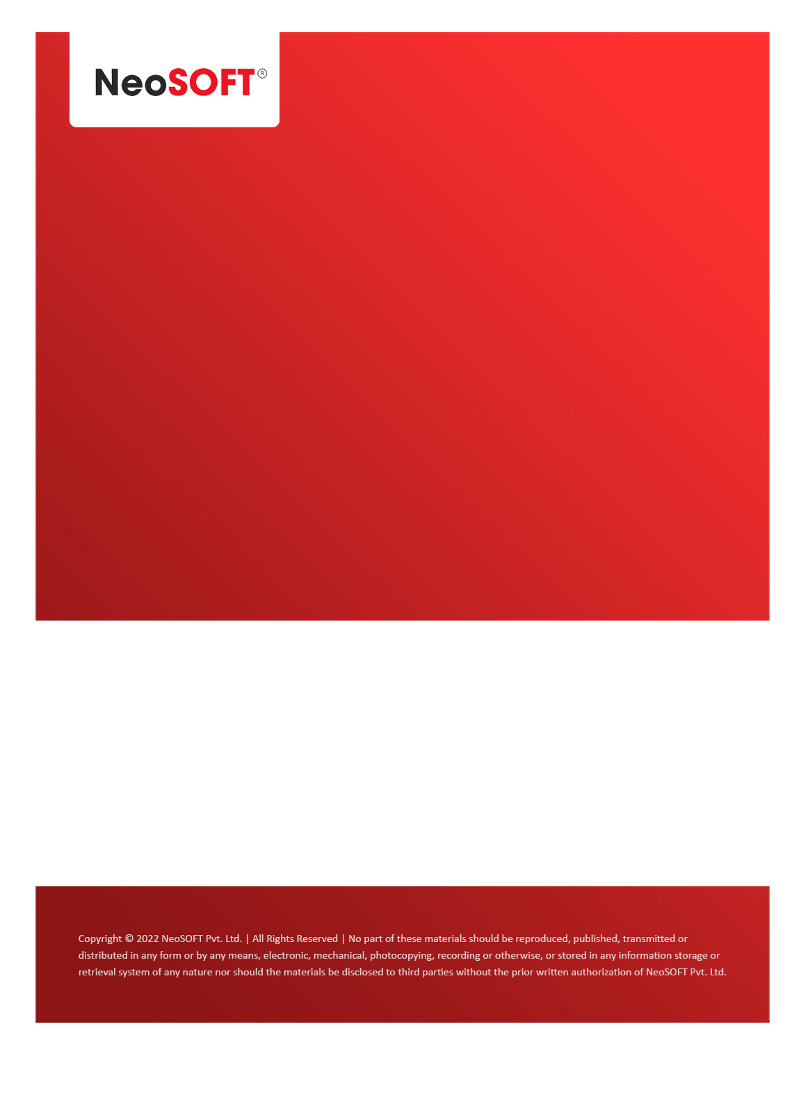`

**Eltizam**

**MOM – RGM 5**

Eltizam

Client Name

NeoSOFT is a SEI-CMMI Level-5 Global IT Consulting & Software Solutions Provider

**April 03**, 2023

|  |  |
| --- | --- |
| **Meeting Date, Time, and Attendee Details** | |
| **Date** | 3rd April 2023 |
| **Venue** | MS Teams |
| **Time** | 05.30 PM – 06.30 PM IST |
| **Meeting Type** | Wireframes discussion, review on work |
| **Internal Attendees** | * YallaReddy * Akshata Shinde |
| **Client Attendees** | * Karuna Pawar |
| **MOM Prepared By** | * Karuna Pawar |

|  |  |
| --- | --- |
| **Details of Meeting** | |
| **Sr. No.** | **Description** |
| 1 | In today’s call, Karuna showed primary review changes from her side on wireframes. So Akshata will work on the same changes. |
| 2 | Most of the changes are from Master level configuration data at this time. So, we will work on next 2 days on these changes. |
| 3 | Will be make changes ready from Akshata’ s end by Wednesday to show it to Vinod & team. |
| 4 | We will get in touch with team tomorrow again on changes to make sure all are on same page. |
| 5 | Scheduling meeting with Vinod’s team and Karthik to discussion project status on Thursday. |

|  |  |  |  |  |  |
| --- | --- | --- | --- | --- | --- |
| **Actionable** | | | | | |
| **Sr. No.** | **Action Item** | **Assigned to** | **Assigned Date** | **Expected Completion Date** | **Status** |
|  |  |  |  |  |  |
|  |  |  |  |  |  |
|  |  |  |  |  |  |